**Why GERMAN is for YOU!** 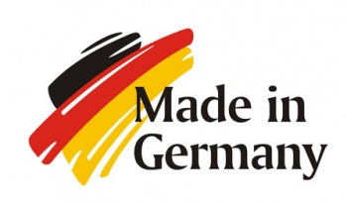

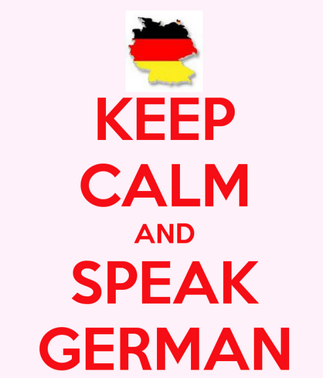

1. **German is not as hard as you think.** *German is similar to English.* German and English are both Germanic languages. They both started out as basically the same language. They share many of the same words, word origins, and grammar characteristics. For example, can you translate these German words: Hand, Maus, Haus, Sofa, Ball, Gras, Ring, Glas, Schule, Vater?
2. **German is the most widely spoken language in Europe**.
3. **Germany has the 3rd largest economy in the world**. Germany has the highest paid workers in the world. More Americans have lived and worked in Germany than in any other foreign country since 1945. Germany and the USA invest $40 billion in each other's businesses per year. **Many companies identify German as the second language they would like their employees to know.**
4. **Knowing German can help you get a job**.

**Over** **500 German companies in Georgia!**

The greater Atlanta region alone has 179 German companies.

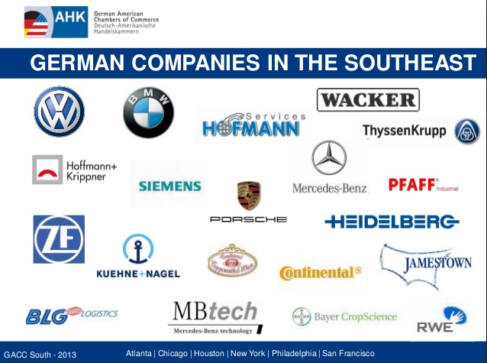

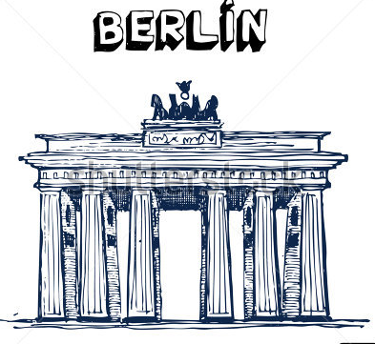

1. **Germans form the largest single heritage group in the USA. You might BE German!**
2. **Germany is a nation of scientists, innovators, musicians, poets, composers, etc.** German is the second most commonly used **scientific** language in the world.
3. **Germany financially sponsors more than 60,000 international exchanges per year.**
4. **TRAVEL to GERMANY with our SFHS Exchange Program – live in Germany for 3 weeks in the summer - go to school – live with a German family – travel the country, experience the culture and the people LIVE and first-hand!**
5. **Universities in Germany are tuition-FREE! Prepare to study in Germany for your Bachelor’s, Master’s, and/or PhD.**
6. **GERMAN is FUN!!! Soccer, Music, Culture – experience it all in GERMAN CLASS!**

**Be COOL – Speak DEUTSCH!**

**Contact Frau Legall-Riddle at** [**slegall@forsyth.k12.ga.us**](mailto:slegall@oconeeschools.org) or **Herr Strecker at** [**jstrecker@forsyth.k12.ga.us**](mailto:jstrecker@forsyth.k12.ga.us) **for more info.**